What is the situation about?
What do I know that connects to this situation?
How does my “role” influence my understanding of the situation?
Where will I go to find the information I need to answer the questions I have?
Do I have all points of view on the situation?
How will I keep track of the information I gather?
How will I communicate what I learn to my team?
Are these resources reliable?
Are they relevant?
How can multiple perspectives impact the data gathered?
What else do I need to take into account? How can I know?
What do I need to do to prepare the resource information for my team?
How will I record and present the information to my team?
Have all my questions been answered?
Is this getting to the problem?
Can I describe my process to someone who does not know this content?
What insights do I have about myself as a learner?
What do I think about my team members as learners?
What do I understand about the concepts and skills contained in this Problem-based Case Study?
How will others know now what I know?
What will I do as a team member in the presentation?
Who will be our audience?
How do I plan to request and process feedback on my work?
Now that I have worked through this Problem-based Case Study, how can I use what I have learned in other situations?

What other questions do I now have as a result of working through this situation?
What is the big idea in this situation?
What seems to be the most important information?
What are the conditions and details that must be met to reach an acceptable resolution?
I think I will list the things I know, my hunches, my questions, and resources for finding my answers.
How do other members of my team see this situation?
Am I listening to them?
Do I feel heard in this process?

What’s in my head? The Learning Cycle from the students’ point of view
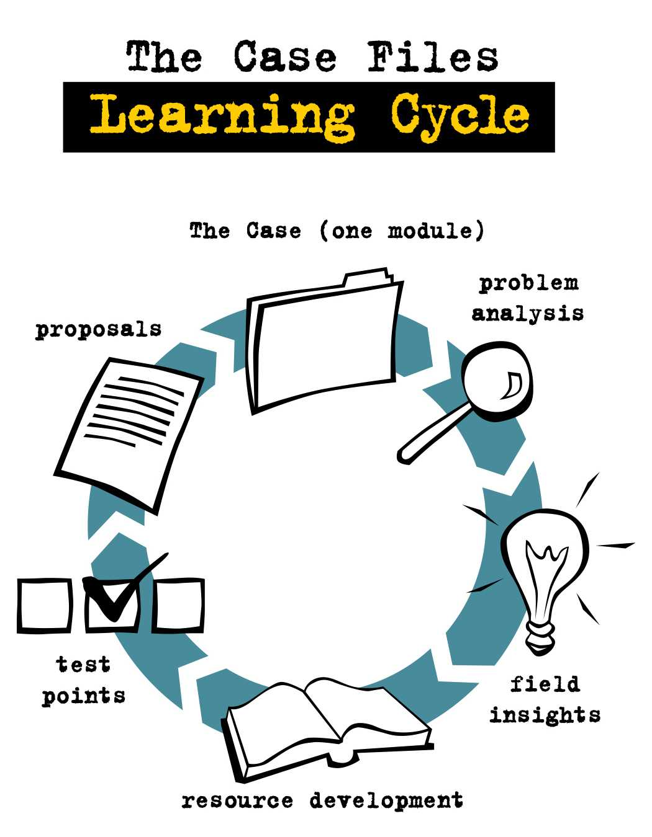
Working the Learning Cycle to reach a reasoned out solution to the Problem-based Case Study requires me to go through the cycle and return again to steps that need revision, clarification, correction, expansion, and so on.
- How well did I do this?
- Do I have a sense of the flow of the process?
- Where in real life do I see this “cycle” in action?
- Could I explain this process to a friend or family member?
- What value do I see in using the Learning Cycle to solve other problematic situations in my life and work?

